Akbarhon Avazkhodjayev

10/16/2020

Project Proposal

CDA4630

Group 38

**Automated Vertical Blind System**

I will be creating the automated vertical blinds system. The MSP430 will be programmed to detect light from the window and depending on the light exposure the blinds will open a certain amount as shown in figure 1. The actual values will be determined later in the project for the motor. The motor will the attached to the string that controls the blinds and will rotate in a clockwise position to open the blinds and counterclockwise to release and close it, depending on what type of blinds I use. This project will be installed into my house for personal use.

**Added Feature –**

1. Use the distance sensor to detect if someone is close to the blinds, so it automatically opens the blinds.
2. 3 – 8 inches will trigger the sensor and the blinds to open and then again to close.

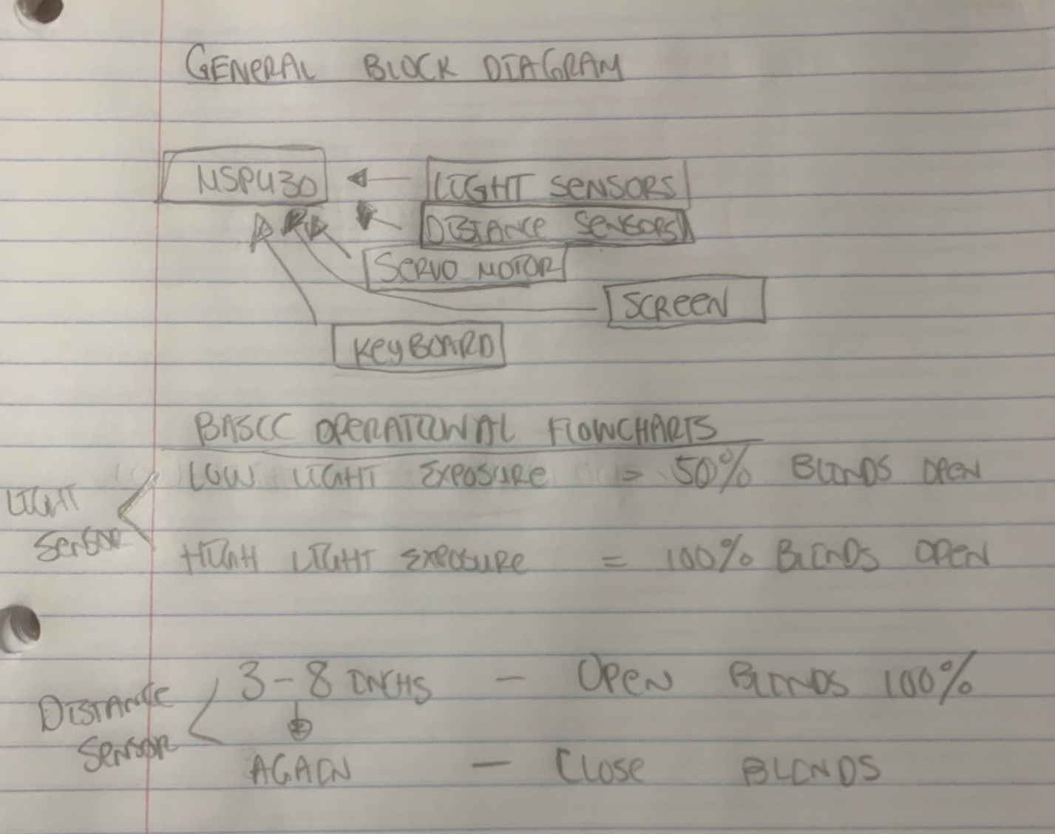

Figure

Components List- I have the parts needed for this project from the lab kits given at the beginning of the semester.